ADMINISTRATION FOR EARLY CHILDHOOD DEVELOPMENT SERVICES AND PROGRAMMES

LEARNER GUIDE

Module # | 234201000-KM-07
NQF Level | level 3
Notional hours | 30
Credit(s) | Cr 3
Curriculum Code | 234201000
SAQA QUAL ID | 97542
Qualification Title | Occupational Certificate: Early Childhood Development Practitioner : L4-131 credits

CONTACT INFORMATION:

Name
Contact Address
Telephone (H)
Telephone (W)
Cellular

TABLE OF CONTENTS

PURPOSE OF THE QUALIFICATION 4
QUALIFICATION RULES 6
EXIT LEVEL OUTCOMES 8
ENTRY REQUIREMENTS: 9
ARTICULATION OPTIONS 10
ASSESSMENT REQUIREMENTS 11
PROVIDER ACCREDITATION REQUIREMENTS FOR THE MODULE: 12
SECTION 1: KM-07-KT01: Early childhood administrative systems and processes (100%) 14
1.1 Requirements for registration 14
1.2 Early childhood programme policies, procedures and records 19
1.4 Types of administrative information and documentation 59

PURPOSE OF THE QUALIFICATION
Purpose:
The purpose of this qualification is to prepare a learner to operate as an Early Childhood Development Practitioner.
An Early Childhood Development Practitioner plans and prepares early childhood activities, facilitates and mediates learning, observes and assesses the progress of children, and reflects on learning in an inclusive, play-based environment to support holistic development of children (from conception - school going) in different centre-based or non-centre based settings.

A qualified learner will be able to:
• Plan and prepare broad-phase learning environment and stimulating activities that meet the holistic needs of all children in centre-based or non-centre-based settings.
• Facilitate and mediate all aspects of the daily programme in a centre-based or non-centre based setting.
• Observe, assess and record each child's progress according to the age and stage.
• Compile a report of each child's progress.
• Maintain and promote the well-being, health, nutrition, safety and protection of children.

Rationale:
The Occupational Certificate: Early Childhood Development has been designed to meet the needs and interests of the early childhood development sector in a variety of settings and contexts with an inclusive focus on education, health and safety issues, amongst others. There is a vast need for early childhood development services and it is critical that the field must be served by competent practitioners. In order to meet the needs at early childhood development level, it is important to be able to identify and recognise competent early childhood development practitioners who are able to work in centre-based and non-centre-based early childhood development settings.

This qualification will provide a means to give recognition to practitioners at an entry level, thus making it possible for practitioners to increase their employment prospects within the Department of Basic Education. The Department of Social Development, through the registration of early childhood development centres and/or sites, may also provide business opportunities to successful practitioners who may wish to establish early childhood centres and/or sites. It will also provide access to a recognised career path and at the same time provide the field with suitably qualified professional practitioners.

The qualification will provide opportunities to people who wish to enter and/or continue learning in the early childhood development field, which include the employed, under-employed but not qualified, and school leavers. Every child has the right to high-quality, holistic education and care which forms the critical foundation for further development and learning from childhood into adulthood.

This necessitates the universal availability of high-quality early childhood development and education as a vital strategy to yield personal and long-term benefits to individual children, their families and the society at large.

Early childhood development is an essential component of economic development within the framework of child care services. Changing social and economic needs require parents to enter the labour market. Therefore quality early childhood development service provision is required to meet growing demands in the country, both in urban and rural settings.
.

QUALIFICATION RULES
This qualification is made up of the following compulsory Knowledge Modules, Practical Skill Modules and Work Experience Modules totalling 131 Credits:

Knowledge Modules: 43 Credits:
• 234201000-KM-01, Introduction to the early childhood development sector, at NQF Level 4, 4 Credits.
• 234201000-KM-02, Theories and Perspectives of Child Development, at NQF Level 5, 6 Credits.
• 234201000-KM-03, Planning and Programme Development in early childhood settings, at NQF Level 4, 8 Credits.
• 234201000-KM-04, Facilitation and mediation of active learning, at NQF Level 5, 12 Credits.
• 234201000-KM-05, Observation and assessment in early childhood development, at NQF Level 4, 4 Credits.
• 234201000-KM-06, Promotion of health, safety and well-being of children, at NQF Level 4, 6 Credits.
• 234201000-KM-07, Administration for early childhood development services and programmes, at NQF Level 3, 3 Credits.

Practical Skill Modules; 43 Credits:
• 234201000-PM-01, Plan and prepare inclusive educational activities and routines using an approved programme based on the curriculum framework, at NQF Level 4, 12 Credits.
• 234201000-PM-02, Facilitate and mediate active learning in an integrated and holistic learning programme, at NQF Level 5, 9 Credits.
• 234201000-PM-03, Observe, assess, record and report each child's progress according to the age and stage, at NQF Level 4, 4 Credits.
• 234201000-PM-04, Support and promote the health, nutrition, safety, protection and well-being of children, at NQF Level 4, 12 Credits.
• 234201000-PM-05, Build and maintain collaborative relationships with parents and other service providers, at NQF Level 4, 3 Credits.
• 234201000-PM-06, Prepare and maintain administrative systems, at NQF Level 3, 3 Credits.

Work Experience Modules; 45 Credits:
• 234201000-WM-01, Learning programme and routines planning and preparation process, at NQF Level 4, 13 Credits.
• 234201000-WM-02, Processes of facilitating and mediating the learning programme in a variety of contexts, at NQF Level 4, 15 Credits.
• 234201000-WM-03, Processes of observation, assessment, recording and reporting on children's learning and development, at NQF Level 4, 7 Credits.
• 234201000-WM-04, Processes and procedures of promoting the health, nutrition, safety, protection and well-being of children in an early childhood development setting, at NQF Level 4, 10 Credits.

EXIT LEVEL OUTCOMES
1. Plan and prepare broad-phase learning environment and stimulating activities that meet the holistic needs of all children in centre-based or non-centre-based settings.
2. Facilitate and mediate all aspects of the daily programme in a centre-based or non-centre based setting.
3. Observe, assess and record each child's progress.
4. Compile a report of each child's progress.
5. Maintain and promote the well-being, health, nutrition, safety and protection of children.

Occupation Regulation
All trades are regulated by the Department of Higher Education and Training (DHET) through the National Artisan Moderation Body (NAMB). To become a qualified artisan you have to pass a trade test at a national trade test centre that is accredited by the Quality Council for Trades and Occupations (QCTO). All national trade test centres are quality assured and recommended for accreditation by the NAMB.

ENTRY REQUIREMENTS:

LEARNING ASSUMED TO BE IN PLACE AND RECOGNITION OF PRIOR LEARNING
Recognition of Prior Learning (RPL):
RPL for access to the external integrated summative assessment: Accredited providers and approved workplaces must apply the internal assessment criteria specified in the related curriculum document to establish and confirm prior learning. Accredited providers and workplaces must confirm prior learning by issuing a Statement of Results or certifying a Work Experience Record.

RPL for access to the Qualification: Accredited providers and approved workplaces may recognise prior learning against the relevant access requirements.

Entry Requirements: • National Certificate Vocational (NCV) at NQF Level 3.
Or
• Any other NQF Level 3 qualification.

ARTICULATION OPTIONS

Horizontal Articulation:
• Further Education and Training Certificate in Early Childhood Development, NQF Level 4, SAQA ID: 58761.

Vertical Articulation:
• National Certificate in Early Childhood Development, NQF Level 5, SAQA ID: 58761.
• National Diploma in Early Childhood Development, NQF Level 5, SAQA ID: 64650.

ASSESSMENT REQUIREMENTS
Integrated Formative Assessment: The skills development provider will use the curriculum to guide them on the stipulated internal assessment criteria and weighting. They will also apply the scope of practical skills and applied knowledge as stipulated by the internal assessment criteria. This formative assessment leads to entrance into the integrated external summative assessment.

Integrated Summative Assessment:
The external summative assessment will be a trade test conducted in terms of Section 26 D of the Skills Development Act through an evaluation of written and practical tasks covering critical aspects of the trade and conducted in a simulated environment at an assessment centre accredited by QCTO by an assessor registered by National Artisan Moderation Body. The assessment will take place over a minimum of 2 days.

PROVIDER ACCREDITATION REQUIREMENTS FOR THE MODULE:

Physical Requirements:
• Training venue/classroom, chairs, desks and tables
• Training material and resources

Human Resource Requirements:
• The trainer must have an NQF Level 5 or higher Early Childhood Development Qualification or equivalent
• Registered Assessor with ETDP SETA is a recommendation
• The trainer with facilitation skills is a recommendation
• Trainer to learner ratio: 1:30 (Maximum)

Legal Requirements:
• Legal Entity
• Accredited skills development provider with ETDP SETA
• Compliant with Occupational Health and Safety legislation and requirements

Exemptions
None

TOPIC ELEMENTS TO BE COVERED INCLUDE:
- The main focus of the learning in this Knowledge Module is to build an understanding of administrative systems and processes, including programme and site registration, children's registration and recordkeeping, including communication with parents.
- The learning will enable learners to demonstrate an understanding of:
- • KM-07-KT01: Early childhood administrative systems and processes (100%)

SECTION 1: KM-07-KT01: Early childhood administrative systems and processes (100%)

Learning Outcome

At the end of this section, learners should cover:

- KT0101 Requirements for registration
- KT0102 Early childhood programme policies, procedures and records
- KT0103 Parent involvement initiatives in early childhood services
- KT0104 Types of administrative information and documentation

Requirements for registration

Guidelines for day care services

The Department of Social Services has drawn up guidelines for anyone wanting to provide care for six of more children. These guidelines say the following about health and safety:

- The ECD centre must be registered with the Department of Social Services.
- The environment in which the children are looked after must be kept in a safe and healthy condition that is in accordance with health regulations.
- Children in this environment must be protected from physical, social and emotional harm or threat of harm from self or others.
- The centre must take as much care as possible to make sure that children and workers are safe from the risk of fire, accidents and or other hazards.
- In disadvantaged communities, the centre must have a nutrition programme which includes providing at least one meal a day.

- When children are ill, they must be managed in an appropriate and responsible way.
- Children with special needs (e.g. a child with a disability) must receive adequate services and treatment in accordance with their needs.
- The centre must respect and protect the privacy and confidentiality of parents and children.
- The centre must have equipment and resources that are appropriate for the ages of the children in their care.
The centre must have administrative systems and procedures so that it can manage the facility and its activities efficiently

South African Government Regulations and Policies for Registration of Early Childhood Development Centres

Staffing Requirements
According to the DSD regulations on day care facilities, staff members must be in the age range of 18-60 years old. Additionally, medical clearance is required for any staff member to be eligible to work in a childcare facility regardless of their position. The DSD requires all staff members to be trained and skilled in first aide. It is required by social services that staff be “knowledgeable and respectful of culture of children.” There are ratios given by the Department of Social Services that require a teacher per number of children within an age group. For children 0-18 months there must be 1 teacher for every 6 children.

Below is the staff requirements section of the table from the Department of Social Development: Guidelines for Daycare.
Staffing Requirements
Age | 18-60, depends on health of person and context of centre. Combination of mature and younger persons.
Attributes and skills | Patience, loving nature, high standard of cleanliness, ability to work in a team. Understanding of, and ability to work with, young children. Supervisor should have knowledge of administration, management skills and financial skills.
Health | Staff appointed must be medically examined before being employed. Staff with infections, illness, must refrain from working with children and food (this does not necessarily mean termination of services).
Culture | Knowledge and respect of culture of children.
Training and experience | All staff should be completing or have completed a basic level training course from a recognized agency covering health, safety, nutrition, child development, administration skills including job description and crisis management. Supervisors/person in charge should have at least a standard 88 or equivalent (and have an understanding of working with adults). Staff development programs are important. In-service training is important.
Language | Mother tongue of child. Knowledge of other languages in an area to introduce to the children.
Staff/child ratios | - House ( mixed age groups) 1:6  - House with additional structures on residential property, daycare centre or hall:  0-18 months 1:6  19 months – 3 years 1: 15  3 years 1 month – 6 years 1:25  After school centre 1 :35  Ratios assessed according space as laid out in the premises category of this document.

Facilities and General Accommodation Requirements
There are many logistics to consider when creating an ECD facility that meets South African registration requirements. Most of the requirements focus on the ratio of the number equipment with respect to the number of children being served. First, there are requirements for bathroom facilities. There must be one toilette and one washbasin or sink for every 20 children. Kitchens or areas used to prepare food must be separated by, at least, a partition if not in a separate room all together. Within the kitchen area there must be a way to boil water for sterilization and to cook food. It is suggested that the floors be washable or have a washable covering. There should also be safe storage for all necessary equipment.

Indoor and outdoor space requirements are mainly based on area per child. Indoors there must be 1.5 square metres per baby and 2 square metres for toddlers. Our group did not find any requirements for older preschool children for indoor play. For children of all age groups it is required that there is 1 square metre per child for outdoor play space. Outdoor play area must be created for the first 30 children and may be used by groups at different times to accommodate larger numbers of students. There must be an area for children who are sick. This may be within a classroom but is suggested to be in an office if available. In order to comply with the Department of Social Development, the many regulations above must be met. The section of the table given by the Department of Social Development:

Facility Requirements
Toilets | The sanitation of the community in which the crèche is situated should be used as the standard. If running water is available flush toilets should be used. Use step-up and adapter seat if normal toilet. Toilets must be disinfected regularlyRatios:1 commode/pottie : 5 children  - 1 toilet : 20 children  For Babies: bucket with lid for sterilizing and soaking nappies. The nappies must be washed daily and the bucket cleaned. There should be a place to change nappies. Separate facilities for washing of potties.  After School Facilities: separate facilities for boys and girls  Crèches must work towards:  - Separate facilities for all boys and girls.  - A potty per child.  - A separate staff facility.
Washbasins | 1 hand basin: 20 childrenUse step-ups if there are fixed washbasins. Water must be changed regularly. Soap and dry cloth must be available. The drying cloth must be changed daily and be accessible to the children. A plastic bucket/container (rather only 10 per bucket) may be used but no water must be left in it after use. Disinfectant should be used in the water. A way of waste disposal is needed – French drain.
Kitchen | Separated from play area by at least a partition. No recommended size. No free access to children, but should be escorted when entering the kitchen. Must be kept clean, hygienic (light washable paint). Equipment should be stored in safe containers. Should be equipped with a table, sink, cooking utensils, crockery and cutlery, cleaning materials. Some means of cooking food, approved refuse removal and cooling facilities. If using gas or paraffin it should be stored outside safely. Washable floor cover. Big enough for utensils and equipment. Not a storage place for toys etc. Separate space (not room) for preparation of baby food. Facilities to boil water for sterilization.
Indoor Space | Indoor play area after cupboards and other furniture has been taken into account:  - 2m² per baby  - 1.5m² per toddler
Outdoor Space | Outdoor play area:  - 1m² per child at least for the first 30 children. Children can then be divided into groups and taken outside one group at a time. Always under supervision.  No open fires in outdoor play area. Public parks may be used as long as it is safe for the children. If no outdoor space add 1m² per child to the indoor space.
Office/staff/sickbay/isolation rooms | A sickbay is a quiet space away from other children even in the same room. IF there is an office, the sickbay should be in the office. If possible a space for staff to rest should also be provided.

How do I register an ECD centre?
To establish and register an early childhood development centre or to apply for changes to an existing registration certificate you must:
- contact the office of the Department of Social Development nearest to the proposed centre
- consult the local authority (municipality) to obtain the right of use and the necessary health clearance certificate to run the centre in a particular place
- contact the local Departments of Education and Health in the area where the early childhood development centre is located to find out if they have any other requirements.

Early childhood programme policies, procedures and records

The legal implications of providing responsible care

There are a number of legal instruments and guidelines that apply to children in South Africa and which describe the responsibilities of ECD workers. If these legal instruments and guidelines are not followed, and there is an accident or injury, you or your centre is legally responsible for it. You can be sued for negligence or charged with a criminal offence if there is an injury. Below is a list of these legal instruments.

The South African Constitution

The Constitution is the highest law in the country. All other laws must follow it. The Constitution contains a Bill of Rights that sets out the rights of every person in South Africa. It says that every child has the right to nutrition, shelter, basic health care and social services. Every child also has the right to be protected from maltreatment, neglect, abuse or degradation.

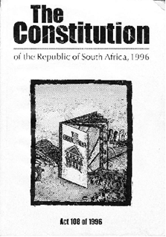

The White Paper on Education and Training
The White Paper says that young children between the ages of 0–3 years have the right to be protected from physical danger, and that they have the right to adequate nutrition and health care.

The Interim Policy for Early Childhood Development (1996)
This policy document says that the ECD centre is responsible for setting up and maintaining a safe and healthy learning environment. The centre is responsible for:

- promoting the physical and emotional well-being of children;
- ensuring access to clean water, adequate nutrition, sanitation, shelter and protection;
- making informed choices that will contribute to the physical, mental, emotional, social, spiritual and educational well-being of children;
- encouraging good health and safety practices in the work/play environment;
- demonstrating the daily routines for children, including supervision/provision of meals, toilet practices, hygiene, rest/sleep periods;
- developing children's awareness of their own capabilities and what is healthy and safe for them to do;
- ensuring that the abuse of children in the learning environment, whether physical, verbal or emotional, does not occur, and countering such abuse where it occurs in the community; and
- demonstrating and encouraging respect for and protection of the environment that arises naturally through practical involvement with the environment.

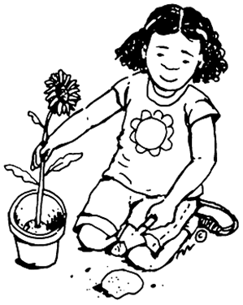

By encouraging children to become practically involved in the environment, you can help them understand why it is important to respect and protect the environment

The Children’s Act 13 of 2005
This act says that children have the right to the care of their family, parents or other appropriate care. They have a right to be protected from abuse, neglect, maltreatment and degradation; and they have a right to social services. The act also promotes equality and protection for children with disabilities.

The White Paper on Health (1997)
This White Paper is concerned with environmental health and the right of children to safe water and sanitation. It also says that communicable diseases, such as TB, HIV/AIDS, measles, mumps, rubella, etc, must be adequately controlled.

The National Health Act 61 of 2003

This act says that children have a right to basic healthcare and nutrition.

Technical Guidelines on Immunisation in South Africa (1995)

The government has prioritised children under five years of age as a target for immunisation and nutritional intervention.

Guidelines for day care services

The Department of Social Services has drawn up guidelines for anyone wanting to provide care for six of more children. These guidelines say the following about health and safety:

- The ECD centre must be registered with the Department of Social Services.
- The environment in which the children are looked after must be kept in a safe and healthy condition that is in accordance with health regulations.
- Children in this environment must be protected from physical, social and emotional harm or threat of harm from self or others.
- The centre must take as much care as possible to make sure that children and workers are safe from the risk of fire, accidents and or other hazards.
- In disadvantaged communities, the centre must have a nutrition programme which includes providing at least one meal a day.

- When children are ill, they must be managed in an appropriate and responsible way.
- Children with special needs (e.g. a child with a disability) must receive adequate services and treatment in accordance with their needs.
- The centre must respect and protect the privacy and confidentiality of parents and children.
- The centre must have equipment and resources that are appropriate for the ages of the children in their care.
The centre must have administrative systems and procedures so that it can manage the facility and its activities efficiently

  - Parent involvement initiatives in early childhood services

Key principles and values in adult learning and community development
As an ECD practitioner you will often have to teach the parents and community members new skills in order to protect or benefit the children. Successfully educating adults is the fastest way to ensure community development.

Adult learning principles and values

In a society characterised by widespread poverty, HIV/AIDS and the erosion of traditional family support structures, investment in the education, health, welfare, care and development of children aged 0–6 is an essential part of the pursuit of South Africa's socio-economic development. Many adults in poor communities have little or no knowledge about the importance to children's development of maternal health, nutrition, physical affection and responsiveness to their needs, and the importance of stimulating children through actively engaging them in learning through play.

It will be part of your job to educate parents and members of the community on how they can help their children to develop.

Compared to children, adults have special needs and requirements as learners:
- Adults need to be free to direct themselves. You must actively involve adults in the learning process and serve as facilitators for them.
- Adults have accumulated a foundation of life experiences and knowledge that may include work-related activities, family responsibilities, and previous education. They need to connect learning to this knowledge base.
- Adults are goal-oriented. You must show adults how what you are teaching them will help them attain their goals.
- Adults are relevancy-oriented. They must see a reason for learning something. Learning has to be applicable to their responsibilities to be of value to them.
- Adults are practical, focusing on the aspects of a lesson most useful to them in their work. They may not be interested in knowledge for its own sake. Instructors must tell participants explicitly how the lesson will be useful to them on the job.
- Adults need to be shown respect and should be treated as equals in experience and knowledge and allowed to voice their opinions freely.

The community context

The children will represent a number of different kinds of communities. Depending on where your ECD centre is situated, the following might be examples:

- The children might come from rural or urban areas
- Some might have running water, electricity and flush toilets at home and others not
- Some might be used to making food on an open fire or a paraffin stove while others might have gas or electric stoves
- Some communities might have more resources than others, for example, a library, swimming pool or other sports facilities

Be sensitive to these differences. Take care not to put children from disadvantaged communities in uncomfortable situations where they might feel less important or less worthy than others. Rather create a sense of equality. Emphasise the fact that all children are equally important and have equal rights.

Community development principles, values and ethics

As a trained ECD practitioner, you will often have to function as Community Development Practitioners (CDP) in your local area. You will be made aware of community problems by listening to the children’s experiences and stories.

Participatory community development wants to empower individuals and groups of people by providing them with the skills they need to effect change in their own communities.

As a community development practitioner, you will sometimes have to assess the needs of others, conduct searches within a community to identify problems, organise family and community meetings, and locate resources and assets such as volunteers, donations and grants. Community developers must therefore understand how to employ the correct behaviour and attitude as well as how to work with individuals.

Values and attitudes to promote working with families

Qualities that promote community development | Barriers to community development
Acceptance  Each person’s personality, ideas, opinions and talents should be accepted unconditionally. Communities can achieve so much more than an individual simply because there is a richness of ideas, creativity and alternative solutions to problems. | Judgemental attitude  A judgemental attitude would mean that you think only your way of doing things is right. In families and communities there are many opinions, skills and knowledge. Being judgemental is disrespectful and denies fellow human beings the dignity they deserve.
Reliance and openness  Family and community members should be able to rely on each other for support and assistance when necessary. This allows people to share and discuss issues without fear of destructive criticism. | Distrust and secrecy  In the ECD centre, the team cannot function effectively if team members do not trust each other enough to share knowledge and skills with each other.
Positive attitude  A positive attitude towards work and colleagues means that you will be willing to help out where necessary – even if that task is strictly speaking not part of your job description. A positive attitude brings enthusiasm and motivation to the workplace. | Negative attitude  A negative attitude is the single most demoralising factor in a team.  “A positive attitude does not guarantee success but a negative attitude guarantees failure.”  – J Maxwell
Unselfishness  Unselfishness means not being so focussed on yourself that you are unwilling to contemplate new ideas – especially when that idea is not your own. To be able to look past your own needs and reach out to other’s opinions, ideas and feelings. | Self-centredness  This means that you have a hidden agenda or a goal that would benefit only you. Self-centred people only look at their own interests and forget about the overall purpose of the team.
Truthfulness  Truthfulness in the workplace means that you adhere to ethical values or set standards of behaviour e.g. honesty and respect. | Dishonesty  Dishonesty often goes with self-centredness. This person would be dishonest as long as her actions reach the goal that she has in mind.
Loyalty  Loyalty within a family or community provides members with a feeling of ‘belonging’ and provides the individual with a measure of protection. | Disloyalty  In families or communities where members are not loyal to each other, there will be a lot of distrust. Members will not be open towards each other because they will fear betrayal.
Flexibility  Although planning is essential in your ECD centre, there are always a number of unplanned events that happen from time-to-time. When this happens team members needs to be flexible enough to change plans, and be able to cope with any unforeseen circumstances. | Rigidity  Rigidity is the opposite of flexibility. It often creates friction between family or community members and may cause them to miss the point. Often there are factors that we do not take into account at the beginning of our planning – these factors may push us off course.
Consultation  Individuals need to consult with other family and or community members when planning events, or when plans change. By consulting with all the role-players before a decision is made, everyone is aware of what is happening and everyone feel a sense of ownership and responsibility towards that decision. | Authoritarianism  This means that there is no consultation or democracy and it shows an attitude of “you do as I say”. This is very demoralising, especially within families, as others feel that they are not valued and that their feelings and opinions do not matter. It will inevitably mean that if the individual makes mistakes that there will be no one to help prevent those mistakes.
Recognition  Recognition is a quality that is essential for relationship building. To acknowledge someone else’s achievements, talents and skills, gives that person a sense of value. It makes people feel appreciated and motivates them to continue and improve work well done. Family and community members need to receive acknowledgement and recognition for their contribution to child/family/community development. | Self-righteousness  This means that you think you can or have done it on your own. You will not be able to do any task as well on your own as you would be able to do it with the assistance of family and community members. Share the recognition for a task well done with the other members of the team. After all:  “One is too small a number to achieve greatness.” – JC Maxwell

Qualities that promote and hinder community development

A participatory approach aims to empower individuals and groups of people by providing them with the skills they need to effect change in their own families and communities. ECD practitioners employing a participatory approach must understand how to employ the correct behaviour and attitude, as well as how to work with individuals.

What is a participatory approach?

The idea behind participative approaches is that the community and practitioners are collaborators on a project. Therefore, participative methods are meant to generate a sense of ownership of decisions and actions. Participatory approaches can also challenge perceptions, leading to a change in attitude and agendas. They can also provide new and sometimes surprising insights.

The challenges for all of us, in these conditions of rapid change and innovation, are many. It is, though, personal change of mindset, behaviours and attitudes, and through these, of values, which is most central. Who we are, how we are perceived, and what we do are crucial aspects of positive change and can provide many starting points.

When applying a participatory approach when working with families and communities, we should immerse ourselves in the communities, allow for critical reflection, learn from poor people, and be prepared for changing roles. If we want to succeed we should remember that relationships, continuity, commitment and trust are the only way forward.

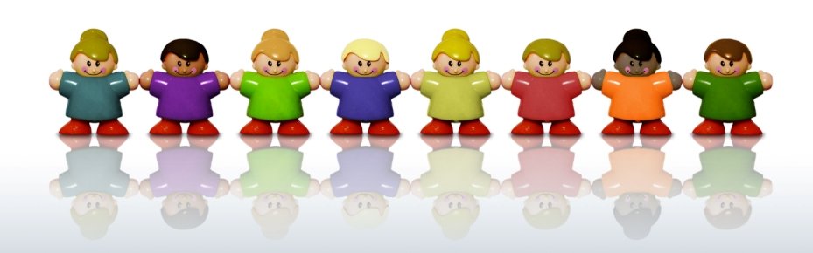

Tools and strategies for working in a participatory way
If you want to be a community development practitioner, you need to ensure that members of the community trust you and see you as a friend rather than a threat. The first step to developing the community, is building ethical relationships with community members. Ethical relationships are basic, honest and trustworthy relationships that one has with other individuals.

If we want to help build our communities, we need to accept that it will take a lot of struggling, learning and sharing, and that the process will never really be finished. Continuity, commitment, trust, and relationships are among the features of ways forward.

What are participatory tools?

Participatory tools are the methods we use to involve people in the community in collecting and analysing information and in deciding on a way forward. They include tools such as ranking problems or issues, doing mapping exercises and other creative methods like role plays.

With all these tools it is important that you observe and listen very carefully and that you make as many notes as possible. It is often best to work in a team so that some of the people can help capture information.

When we use participatory tools:

- The development practitioner and the community learn from each other. So group learning occurs.
- The development practitioner facilitates the involvement of the community and interaction between people. He or she helps the community to carry out their own study.
- There is a lot of group work. Different individuals and different groups will have different interpretations of a situation. You usually use the participatory tools with different smaller groups and then you use them to bring all the information together to compare results. It is useful to group people according to the differences that you may wish to explore. For example, you could ask the men to form one group, and the women another. In this way you can pick up important differences in interpretations.
- You can be flexible and make up your own way of collecting information to suit a particular situation.
- We can capture a great deal of detail as well as patterns and trends.
- The community feels a sense of ownership of the process and the information that has been generated.
- Participatory tools lead to change. The methods encourage a lot of discussion and interaction and communities start coming up with their own solutions.

There are many factors within the family context that will have an impact on the child. Position in the family, socio-economic status, family stress and change will all have an impact. Let’s look at why we should involve families and communities in our ECD centre activities.

The importance of involving families

Parents and guardians play an important role in the ECD centre. They share the responsibility of the education of their children with the ECD practitioner. Parents or guardians are the child’s role models and primary ‘teachers’.

Children learn how to deal with life and make decisions based on the way their parents and others around them behave. It is, therefore, essential for all caregivers to be aware of the significant responsibility that they have towards the children in their care. All caregivers need to instil a sense of self-worth, security and unconditional love in their children. Apart from care giving and teaching values, families are involved in their children’s development from birth. Often, however, they would welcome more support or information to allow them to play this role more effectively.

The parent, caregiver or guardian plays a vital role in developing unique and worthwhile human beings. Parents, guardians and caregivers need to be encouraged to get involved in their children's education. They need to be actively involved in developing their children's beliefs and values and in supporting their children's learning in appropriate ways.

Parents or families as partners with the ECD centre

Extensive studies have shown that parent or family involvement helps children cope better at their ECD centre. When ECD centres involve parents in programmes that are well-structured, it benefits both the children and adults involved.

With regular parent or family involvement, a child will experience:

- improved achievement and motivation;
- a good attitude towards the ECD centre and the ECD practitioners;
- improved behaviour and attendance;
- an improved self concept; and
- improved communication with the ECD practitioner and the family.

Establishing a working partnership


ECD practitioners must create successful home-school partnerships and mobilise parents, community members and social service agencies to engage in true collaboration on behalf of children and their families. This view sees the ECD centre in the much broader context of the community and asserts that children's life chances are not likely to improve without collective action in many arenas – the ECD centre, the family, the local health clinic, the neighbourhood, the block, the home, and so on.

Several ECD centres are implementing programmes in which family and community members collaborate in a variety of ways and coordinate their services for at-risk children.

Working in partnership:

- Builds trust between educators, parents and communities
- Builds a comprehensive support system for children and their families
- Increases the knowledge about the needs of the students and their families

Partnerships should build upon all of the community's resources in addressing the needs of children and families. They should include parents, health and social service agencies, community organisations, businesses, educational institutions, and so forth. Indeed, involving parents as participants in the ECD centre – as tutors, programme coordinators, volunteers, and community liaisons – is essential to building a climate of nurturing and engaged learning in the school.

Acknowledging indigenous socio-cultural knowledge and practices

Indigenous and socio-cultural characteristics

Each community has distinct indigenous and socio-cultural characteristics that make it unique. Many of these characteristics are strongly influenced by the cultural values of community members.

It is never a good idea to assume that you know more than a child’s family. The families and community members will have their own knowledge and understanding of the child concerned; however, they may also have knowledge and experience that stems from their cultural beliefs and practices.

Gaining information and knowledge about the communities to which children belong is an important starting point in developing a holistic approach to cultural diversity in children's services. It enables ECD practitioners to develop strategies for linking with communities that are culturally respectful and appropriate.

Indigenous knowledge and socio-cultural links should be fostered continually not just at ‘special events’. You can often gain the most meaningful information from parents during small talk that occurs when a trusting relationship has been developed between staff and parents.

ECD practitioners who are committed to reflecting the values, beliefs, and experiences of children, their families and the community in which they belong can capture a community’s indigenous knowledge and socio-cultural practices.

Family structures

The children’s family structure will differ. There may be single parent families. Children from divorced parents can have one or both parents involved in their lives. Parents can be married – legally or traditionally – or live together. There may be children that live with only parents and siblings, and children that live with extended families – grandparents, uncles, aunts and cousins. Some children may be the only child while others may have many siblings. The family composition will play a role in aspects such as the physical space a child has at home. A single child might have his or her own room whereas children from big families often share rooms.

Case Study
There is a girl in your class whose name is Noxolo and her teenage sister is the head of the household. Both Noxolo’s parents died due to HIV/AIDS complications and the four children are now struggling to get along without their parent’s emotional and financial support. Noxolo is HIV positive. The other children (and their parents) might not understand how a girl cannot have any parents. The parents might also be scared that their children might ‘catch’ HIV by using the same eating utensils as Noxolo.

You also have a boy called Yin in your class and he is the only Buddhist Chinese boy in the class. Most of the children have never met Chinese people before and they find his manner strange and you have heard one child saying that his mother’s packed lunches are ‘disgusting’. The other children might not understand why Yin bows when he says hello or why he sometimes eats food that varies from theirs. Most of them will also be new to the concept of Buddhism and the parents might not like them being exposed to it.

Think about how you will make both Noxolo and Yin feel more welcome in the class and how you will teach the other children to accept them as individuals.


How to conduct your own participatory needs survey

What is a participatory needs survey?

A participatory needs survey is an effective way for you to learn more about your ECD centre’s surrounding community. You will use this type of survey if you want to, for instance, research the family structure of each of the children in your class.

Community-based participatory research recognises the community as a unit of identity; builds on strengths and resources within the community and facilitates partnerships in all phases of the research, involving an empowering and power-sharing process.

What can a participatory needs survey achieve?

Participatory needs surveys can help you to assess your ECD centre’s children’s home and community situations and detect underlying problems. Once you know what you are dealing with, you can help address the issues with information sessions and capacity building exercises.

How to conduct your own participatory needs survey

When planning your participatory needs survey, you can use the five W’s journalists use when writing an article. You should draw up a planning list and it should include: Who, what, where, when and why.

Who do you need to speak to and who will conduct the survey?
Who do you need to speak to? It will probably involve your ECD centre’s children’s parents and sometimes it could also include various members of the local community. These can include community stakeholders like other family members, social workers and community figures like nurses, priests or shop owners.

You have to decide whether you will do the interviews yourself or whether you would like to split the interviews with someone else. Ideally, you want someone with very good people skills who can make the interviewees feel relaxed.

What information do you need and why?
What information do you wish to receive? With a participatory needs survey you will most likely be looking at the children’s families and local community and their collective needs, practices, viewpoints, knowledge and available resources. You need to be specific and preferably only look at one issue at a time.

Then look at why you need this information. Do you get the idea that the children in your class have various family structures and do you want to find out what these are in order to include them in your learning activities? Do you sense that some parents have not immunised their children and do you want them to learn more about the importance of sterilisation? Remember that adults will always be interested in why you need certain information.

When and where are you going to speak to the research participants?

When are you planning to conduct the research? A week is a good time frame to plan for. You also have to decide whether you will be conducting the survey at your ECD centre or whether you are going from home to home by way of home visits.

How will you conduct the survey and how will you inform the participants?

A written survey form is one tool you will need to complete the surveys. One of the most important aspects of the participatory needs survey is to use open questions and not to let the participants feel that any answer is right or wrong. Answer their questions and make them feel at ease.

DEFINITION
Open-ended questions: questions that encourage the speaker to elaborate on their answer e.g. “How did you feel about ...?”
Closed questions: questions that encourage a one word answer – usually yes or no e.g. “Did you agree with the new policy?”

The best way to inform parents of an upcoming survey is to put up posters in your classroom as well as send out letters. For successful interviews, you will have to develop a level of trust between yourself and the person you are interviewing. You could do this by assuring the interviewee that what they tell you will remain confidential. You can also invite members of the community by putting up posters at libraries or sending out invitational letters.

Example of a participatory needs survey

Participatory needs survey example

Topic: Family culture and structure

Aimed at: Parents of the children at your ECD centre

Remember: an interview makes more use of discussion and open-ended questions where there is no one ‘right’ answer. Rather you encourage people to speak about their opinions and experiences.

Basic questions to cover:

1. What culture would you say you belong to?

2. How many of the following members does your household have?

1. Mother
2. Father
3. Sister
4. Brother
5. Grandmother
6. Grandfather
7. Uncle
8. Aunt
9. Other

Sum up the interview and thank the person for their time.

Home visits
Home visits can be trickier than conducting surveys at your ECD centre. Be sure that you are prepared and do your utmost to make the person feel as relaxed as possible.

Home visit checklist | Tick
Arrange a time that you will visit the home and make sure your timing is convenient.
Prepare and write down your questions beforehand.
Take pen and paper along to write down the interviewee’s answers.
Be friendly and encourage people to feel relaxed by starting with general questions.
Explain why you need the information and that it will be treated as confidential.
Ask open questions to encourage people to express themselves.
Ask your questions in a clear, conversational and simple way.
Actively listen to their answers and make sure that you understand what the person is saying. Ask the person to clarify if you do not understand.
Jot down notes about the main points made.
Do not interrupt the person or give your opinion on the topic; this is about them.
Summarise your questionnaire at the end of the interview.
Thank the person for their time.
Home visit checklist

DEFINITION
Conversational: to speak to another in a clear and concise way. To communicate in an informal style.

Interpreting the survey results and giving feedback

Organise the responses you received in a clear and logical manner. Be flexible and objective as the feedback you get will not always be what you have expected or what you wanted to hear. We are trying to learn more about our communities, not trying to prove our own points.

Write down the information or data you received and write a summary of what you can conclude on the basis of this data, and what you plan to do with it.

After drawing conclusions from the results, you have to give feedback to the parents or community. You can do this by planning an event or inserting an article in your ECD newsletter. If you do not have a newsletter, send out a letter to parents. Include interesting bits of information like “Did you know that half of the children at our centre have single parent families?” but never include personal information like “Mrs Naidoo said that she would have preferred to raise her son with the help of his father”.
Parent meetings

It is a good idea to have regular parents meetings in order to give feedback to parents on their child’s development, assess what has worked and discuss what can be improved on in the future. Parent meetings provide a connection and partnership with parents to discuss a child's needs, strengths and areas to build on. Parent meetings are an important way of allowing parents to be part of the process of setting goals for the school.

1. Be prepared
Prepare in advance for the meeting by using a checklist (see table 2.2). Even if the children are only infants, this time is set up for you as a practitioner to gain a better understanding of both the child’s and the parent’s needs. It is a good idea to write out a report for each parent with details on how their child is developing. If the parents cannot make the meeting, you can give it to them when they next pick up their child. Remember to cover areas such as speech, mobility, social skills, game play and art.


2. Encourage parents to show up
The idea behind parent meetings is to encourage communications with parents, but please remember that a parent’s time is precious. Ideally you need to send a letter with the children informing parents of the meeting and ask the children to bring back a signed slip if possible. Put up a poster with the date and time to remind parents when they pick up their children. A reminder two days before the meeting might also help to increase attendance numbers. If you have something specific to discuss with parents such as a possible problem, please ask them to stay on after the meeting in order for you to discuss it with them in private.

3. Be positive
Even the strongest partnerships between providers and parents seem awkward in a formal setting. Defuse any nervousness by beginning the conversation in a positive light. Briefly mention a highlight and reserve at least one compliment for each parent, for example, Suzy is a really good communicator. This serves as an icebreaker and begins the conversation in a positive tone.
4. Stay on topic
This conference is about the children, and concerns the present and not the past. This may sound simple, but parents will often start talking about their own childhood, another sibling, or other matters that have nothing to do with the topic at hand. Remember, this is your time to talk about how the parent’s child is doing in the childcare setting. There are plenty of other opportunities to have casual conversations with the parents.

5. Make time to also listen and be open minded
A parent’s meeting is a chance for caregivers to provide parents with information based on observation and daily care. No child is perfect, and remember that you have to bring up information of value to the parents, even if it may offend them. Remain open minded and receptive to feedback that you may get, and don't become defensive about discussions of behaviour or areas that need to be worked on.

6. Involve parents in the centre’s activities
Remember that the parents must feel like part of the centre, and that you can achieve this by incorporating their ideas when planning the centre’s activities. Although most parents have busy lives, you may be pleasantly surprised by how willing they are to help out with occasional outings, talks or volunteer activities.

7. Take notes
Take notes during your meeting. Some ECD centres have a checklist or sheet completed on your child that is left with you following a conference. Notes help you remember the high points and areas of concern, and to help work on those behaviours for improvement. Remember, the conference also serves to talk all about the areas each child is doing well in, and allows you the chance to reinforcement these achievements.

8. Set follow-ups and future feedback
If you have to ask parents to help with corrective action to help improve behaviour and development, schedule a follow-up appointment. If a boy is biting other children, work in partnership with the parents to resolve the situation. Try to establish open and ongoing communication tools to foster stronger relationships all around.

Parent meeting checklist | Tick
Parents:
Invite the parents at least a week or two in advance
Send parents a reminder a day or two before the meeting
Make sure that you create a friendly informal environment
Schedule:
Plan your time and allow enough time after the meeting in case parents have something they wish to discuss with you
Resources:
Organise refreshments or ask parents to each bring something if they are able to
Have paper and writing materials available
Including the children:
Make sure you have some of the children’s arts and crafts on display
Parent meeting checklist

Other ways of communicating
You have to open up as many communication channels as possible in order for you to always stay in touch with the children’s parents.

Notice board

It’s a good idea to place a notice board on the wall next to the door of your centre, where parents will often pass by when they come to pick up or drop off their children. Try to make important notices stand up and include some pictures and highlights on the notice board to give it a friendly feel. You can also include photos on the notice board to help parents see what is happening during the day.


Personal message book

Each child should have a little notebook that they carry in their bag every day. In this book you will write or paste notices of events and outings that will take place. You will also write down items that the child should bring to class for craft purposes e.g. old cereal boxes or magazines. Ask the parents to regularly check and sign the personal message books.

Modern technology

You can use phone calls, SMS, and email to keep in touch with parents. Just make sure to ask parents whether they have regular access to the Internet before you use this as the predominant medium of communication. You could also ask parents which communication medium they prefer as some people love sending and receiving SMS’s whereas others would much rather speak to you on the phone.
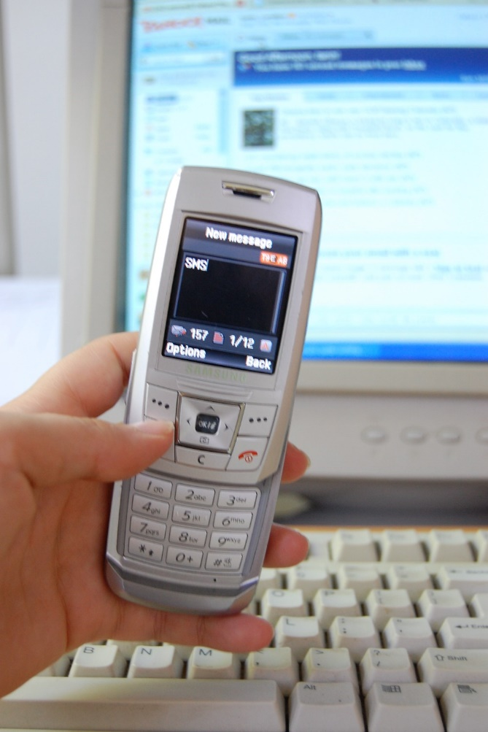

Figure 2.1 As an ECD practitioner you can use modern technology, such as email and cellphone SMS’s, to help you keep in touch with parents

Home visits or individual appointments

It is ideal to have occasional home visits, as this will allow you to see the parents and children in their home environment where they are (usually) relaxed and at ease. You can alternate home visits with individual appointments or stick to the latter if home visits are not possible due to transport problems or shortage of time/staff.

Newsletters

Newsletters can be a great way of communicating with parents if you have enough time and resources available. It doesn’t have to be very time consuming and expensive though. Sometimes one black and white A4 page once every quarter can be enough to keep everyone informed of the comings and goings of your ECD centre. See figure 2.2 for an example of an ECD centre newsletter.

Items to include in newsletters:

- Events
- A positive note from you to the parents
- Tips for dealing with early childhood development
- Items that parents can contribute to the school (if applicable)
- Children who recently joined the group
- Birthdays
- Relevant articles
LITTLE TOTS  PRE-PRIMARY SCHOOL  NEWSLETTER NO. 1  email address: info@littletots.co.za  website: www.littletots.co.za  Tel: 021 456 7891 |  | 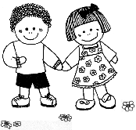  Date: July 2008
Dear Moms and Dads  Welcome back to another term at Little Tots. We hope that you all had a super time with your families. The staff are all looking forward to a happy and exciting 3rd term with your children.  We have a few new and exciting things happening this term that will enrich your children further.  During the holidays we started work on a movement area in the back garden. It will be a supervised area where we are providing apparatus to encourage gross and fine motor development. Babette will be taking small groups through this area on a Tuesday and a Thursday guiding the children as to how the equipment works.  Thank you for your interest and support.  Yours sincerely,  Sharon Green  Principal | ANNUAL ‘CHRISTMAS CAPER’ BOOK SALE  This will be held in the main hall on Thursday and Friday 6 and 7 November.  It is a wonderful opportunity to stock up on Christmas presents and holiday reading. The brand new books are available at very reasonable prices, with many around R30–R40. The company which provides the books is owned and run by two former teachers.  The books are mainly for children but as usual, there will be some books suitable for adults.  A book is a gift that lasts a lifetime, as reading – and the success it brings – is a lifelong joy. | Themes for the week:  Dolphins  Road Safety  Whales  Transport  Starfish  Healthy food  Ladybirds  Our Country S.A.  Rainbows  Birds  Dates to diarise:  7 July: Parent’s Meeting: 7pm.  25 July: Outing to aquarium  31 July: Open Day
Art exhibition  Thank you to all the parents and family who were present at the official opening and who visited the exhibition during the set times. Your interest is valued. | Dance Photos  Orders are being taken in the office. R45 per framed photo or R25 per copy. Have a look they are all super! | Wise words  “Life is a field of unlimited possibilities.” –Deepak Chopra

Example of an ECD newsletter

The ECD centre has a very important role to play in the provision of information and resources to the family that will assist the family to meet the needs of their children. In most communities the ECD practitioner is seen as a professional with specific knowledge regarding child development and related issues. In this regard the ECD practitioner has a social responsibility to share their knowledge and skills. This sharing of knowledge will contribute to the development of the families and communities.
Legal Advice
ECD practitioners should keep themselves informed on legal issues affecting children below school going age. You should know that the parents of your ECD centre’s children have legal duties towards them and that they must give these children enough support to survive, including food, clothing, housing, medical expenses and education.

Although everyone has their own opinion on using force when educating children, the law stipulates that parents have a right to punish and use reasonable force when children behave badly. If a parent uses unreasonable force, however, the parent can be charged in a civil or criminal court.

Laws that provide protection for children who are abused include:

- The Child Care Act, which says it is a criminal offence if a person who is supposed to maintain a child doesn't provide the child with clothes, lodging and medical care.
- The Domestic Violence Act, which defines the different forms of domestic violence against adults and children and says how a child can get a protection order against the abuser.
- The Basic Conditions of Employment Act, which makes it illegal to employ a child under 18 years.

DID YOU KNOW?
The Children’s Amendment Act (Act 41 of 2007) states that a “person unsuitable to work with children is not a fit and proper person to provide or assist in the provision of early childhood development programmes”. Sex offenders, therefore, are totally forbidden to be employed at ECD sites.

Healthcare resources

ECD practitioners often have to help make parents aware of the local health resources at their disposal. Not all parents may know that the National Department of Health (DoH) provides free healthcare services for children under the age of five and pregnant women, and that poor communities are served by outreach services.

The DoH have an integrated management of childhood illness plan that aims to promote healthcare and prevent illness through monitoring and promoting growth, immunisations, homecare counselling, de-worming and promoting breast feeding. It also plans to cure by assessing, classifying and treating and offering rehabilitation services in accordance with provincial protocols.

Many children are living with HIV and AIDS and many babies are born with HIV. These children face many forms of neglect and discrimination. For example, babies are abandoned; children are refused access to ECD centres and schools. The government has active AIDS and TB programmes to deal with broad issues relating to the AIDS epidemic and to help treat TB.

DID YOU KNOW?
Worldwide more than 750 000 children under five die each year from malaria, most of them in Africa where it is the main cause of infant mortality.

Family resources

There are many non profit organisations (NGOs) in existence today to help families in need as well as NGOs that specifically cater for certain problems such as abuse or helping to fund terminally ill children. It’s a good idea to create a list of local NGO’s as well as some national organisations that can cater for children in your centre with specific needs, such as diabetes or learning problems.
Find a local social worker that is willing to assist you with queries and ask him or her to help you with the creation of your family resources list.

South African social services include:

- Preventative services that protect the family unit and prevent abuse and neglect.
- Protective services that protect children from abuse and neglect.
- Rehabilitation services, when preventative or protective services fail.
- Special services aimed at children with special needs.

The Family and Marriage Society of South Africa (FAMSA) was established to initiate and coordinate resources to maintain a healthy and happy marriage and family life. They believe that the family is the nucleus of society, and when it weakens or crumbles the stability of the entire community is adversely affected. They employ social workers with specialised training to assist the community and supplement their manpower by recruiting volunteers from the community.
DID YOU KNOW?
You can call FAMSA’s national office on (011) 975 7107 or visit http://www.famsa.org.za/ to find your local FAMSA branch. They will also be able to put you in contact with other family resources in your area.

Families with special needs

Sometimes there will be special circumstances in the child’s family. These children may need special assistance from the ECD centre. Let us look at a few examples and how the ECD practitioner will be able to assist such families.

- Health issues: family member with HIV/AIDS, terminal chronic illness or disabilities;
- Economic issues: breadwinner who is unemployed; working parents;
- Social issues: abuse; families in transition – going through a divorce, birth of sibling, moving home or the death of family member.

Grants and governmental support

Part of your role as ECD practitioner is to familiarise yourself with the resources that the government offers to help with the Early Childhood Development process. Get to know government’s ECD documentation as well as the grants they have on offer.

Many ECD centres that offer Grade R teaching are independent institutions that are supported financially by their province’s education department. To qualify for financial support, ECD centres must register with their province’s education department.

All ECD practitioners who have achieved a Level 5 qualification need to be registered with the South African Council of Educators (SACE). There has been discussion about the registration of Level 4 graduates too, and you should keep informed about this.

DID YOU KNOW?
South African Council of Educators
Web: http://www.sace.org.za/
Email: info@sace.org.za
Tel: 012 663 9517
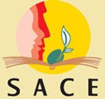
Fax: 012 663 9238

Child support grants

A child support grant is money paid to the primary care giver of a child to provide for the child’s basic needs. The monthly child support grant from April 2008 is R210.

The following people can apply for a child support grant:

- The primary care giver of the child or children concerned. The child and caregiver must be South African Citizens or permanent residents.
- A child or children under the age of 14.
- The caregiver and spouse must meet the requirements of the means test.

Other types of support

Parents cannot look after their children all the time. Single mothers often need to work long hours and sometimes need some time on their own to relax. Mothers and fathers also sometimes need to spend some quality adult time together. Families that do not need financial or social services support often only need some emotional and babysitting support.

Parent childcare network

A great idea is to initiate a parent childcare network. All you have to do is to write down the details of all the parents that want to be part of the network in a table such as below.

Parent childcare network
Parent/s name | Child(ren)’s name | Telephone | Address | Times Available
Sarah Bailey | Zoë Bailey | 021 557 6545 | 5 Chateau Road | Wednesday pm
Jo-Anne Cloete | Elroy Cloete | 021 566 1232 | 7 Sante Claire Road | Monday pm
Example of a parent childcare network schedule

The parents can then contact each other and make arrangements. For example, Sarah is attending an extra course on Monday nights and Jo-Anne likes to go to aerobics on Wednesday nights. They can then make arrangements that Zoë can stay at Jo-Annes on Monday for two hours, whereas Sarah will look after Elroy for two hours on Monday nights.

This is a great way for parents to become friends and to be able to offer each other childcare as well as emotional support. Parents can also get to know each other at parent meetings.

Babysitters

You can put up a few babysitting adverts on your ECD centre notice board, preferably only those with good references. Take down adverts of babysitters if the parents complain about them. Add a note stating that the centre is not responsible in any way for the actions of the babysitters and that parents should contact references before using them.

Religious groups

Churches and other religious groups often offer financial and emotional support for children as well as families. You can put up their details on your notice board if you wish.

Understanding child development
Let’s have a look at how knowledge about how young children learn can help the ECD practitioner to make decisions about how to improve the learning programme

      - Concrete learning experiences

From birth to the age of three, children primarily use their senses to explore concrete objects. During this phase they have to see, hear, touch, taste and smell to learn.

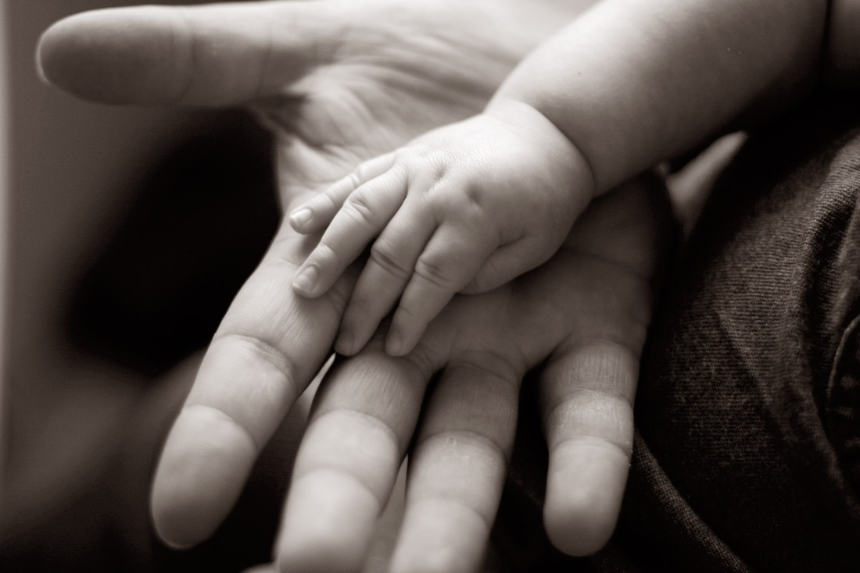

Babies use their senses to explore the world around them

      - Semi-Concrete learning experiences

Children between the ages of three and five years of age are able to relate pictures to the real objects that they explored earlier.

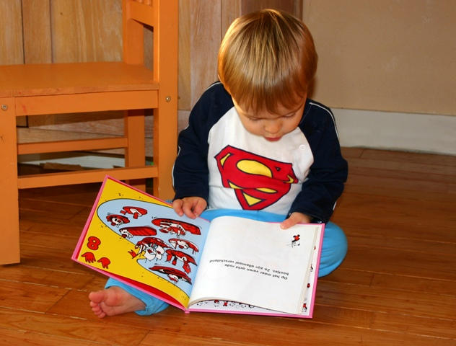

Children between the ages of three and five are able to relate to pictures of real objects

      - Abstract learning experiences

Children from age 5 can grasp the meaning of symbols and abstract concepts that cannot necessarily be explored by their senses.

It should however, be noted that although this is generally true, the learning process is like climbing steps. Once a particular skill is mastered it continues to be used during the phases that follow. For example the 5-year-old child that is capable of abstract learning still uses his/her sense of touch to explore the texture of new objects.

This knowledge will assist the ECD practitioner to make decisions regarding how to create activities that will specifically focus on the child’s developmental stage. For example, include objects of different textures in the baby room.

Raising awareness in families about child development
The good news is that children do not necessarily need expensive educational toys to enhance their early childhood development process. Parents can encourage development by learning some basic techniques. Try including an early childhood development tip in every newsletter you publish or put up tips on your centre’s notice board. When parents come to you for feedback sessions or meetings and mention problems that they have, you can help them by mentioning ways they can enhance their child’s development.
Raising awareness about children’s rights

Children’s rights in South Africa

Our constitution stipulates the rights of children in South Africa. Let’s read through the children’s bill of rights together. In this section a child is a person under the age of 18 (The Constitution of the Republic of South Africa 1996, Section 28 of Act 108).

Every child has the right to:

- A name and nationality
- Family, parental or appropriate alternative care when necessary
- Basic nutrition, shelter, health and social services
- Protection from maltreatment, neglect, abuse or degradation
- Protection from exploitative labour practices for example: not to be expected to perform work or provide services that are inappropriate for the child’s age or place at the risk of the child’s education, physical or mental health or spiritual, moral or social development.
- If detention is unavoidable the child should be kept separately from persons over the age of 18, and the conditions of detention should take into account the child’s age
- Have a legal practitioner at the expense of the state
- Not to be used in direct armed conflict and to be protected in times of armed conflict

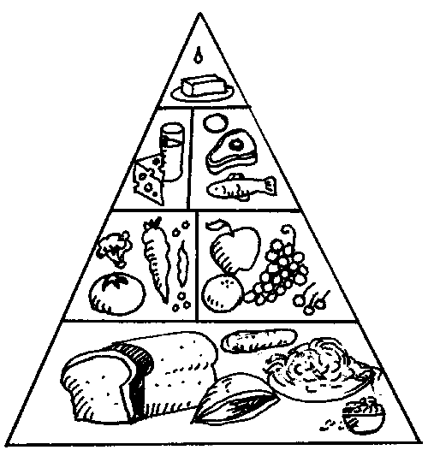

Every child has the right to basic nutrition. Good nutrition is met by following the basic food pyramid

The child’s right to education

The child has the right to:

- Basic education and to further education which the state must make progressively available and accessible
- Education in the official language or the language of their choice as far as practically possible and with taking into account equity, practicability and the need to redress results of past racially discriminatory laws and practices

Knowledge of these constitutional rights can assist the ECD practitioner to make a meaningful contribution through advocating and lobbying in the community for these rights. This means that the ECD practitioner can play a key role in making the parents and broader community aware of the fact that an early childhood education should not only be a priority, but the quality of that education is of utmost importance.

 | DID YOU KNOW?  Biblionef, an organisation based in Cape Town, distributes educational books to organisations and projects. They also commission books in mother tongue languages for young readers. They distribute a book called The Rights of the Child, which is available in all 11 languages. It also contains a summary of the Declaration of the Rights of the Child.  The cost of the book is R50.
Rights and responsibilities: A child’s perspective
Table 2.4 below looks at some of the rights that children are entitled too, as well as the responsibilities that accompany these rights.

The rights of all children are: |  | The responsibilities of the child are:
1 | To enjoy the very best the world can offer | To look after the world s/he lives in i.e. not to litter
2 | To grow up in freedom and dignity | To give other children a chance to enjoy these freedoms too
3 | To have a name and a country of your own | To include/play with children across all cultures, races and countries
4 | To be fed when hungry and nursed when sick | To eat healthily and not to waste food
45 | To get special care if they are disabled in any way | To accept and support children who are disabled
6 | To have a family that loves and cares for them | To love and care for their own family or carers
7 | To go to school and not to have to work to earn money | To do their best at school
8 | To be helped in times of trouble and danger | To alert adults if they become aware of dangers
9 | To be protected from neglect, cruelty and abuse | To care for their own e.g. pets, younger siblings
10 | To be loved and in return spread peace and understanding | To show love and understanding to the people they meet
11 | To be encouraged and able to play | To play
Table 2.4 Rights and responsibilities from a child’s perspective

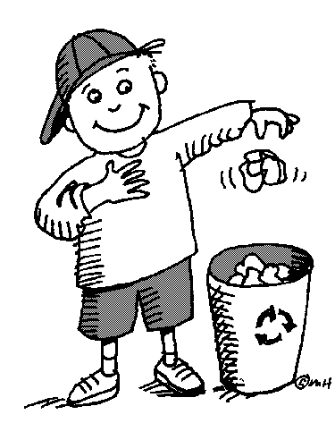
Children have the right to the best the world can offer, as well as the responsibility to help look after the world we live in
The role of the family in supporting child development and children’s rights

Young children learn by modelling behaviour. It is very important that parents are aware of this as they are the most important educators in the child’s life. Children learn how to process emotions, treat other people and handle conflict by watching their parents.

The ECD centre can help to educate parents about their role in supporting child development and children’s rights and provide support for them to become more effective parents. Workshops on positive discipline, managing temper tantrums, or development phases could be hosted by the ECD centre. Short articles in the ECD centre’s newsletter could be of interest to the parents.

How to approach families
Let’s look at how you can approach families in a sensitive, non-offensive yet effective way.

Create a complementary environment

You will need to create an environment at your ECD centre that complements the other aspects of the child’s life. The child’s learning experiences will be more integrated if there is a ‘cross-pollination’ between the home and the ECD centre. Ideally some rules, values, norms and discipline should to some extent overlap, so that the child will feel a sense of security and familiarity regarding the caregiver’s expectations. If there are too many differences, the environments may be more conflicting than complementary.

Get to know the children in your ECD centre

Observe the child and their families. Look at how the child and parents are dressed and whether they observe certain cultural or religious practices like prayers or dressing in a certain way.

Take time to talk to the family members as they bring or fetch the children; give them feedback about the day’s activities and use this time to gather more information about the child. Ask the children and their families about their specific traditions, and ways of living at home, what is allowed at home and what not, home routines and how discipline is enforced. This will most certainly offer a host of information about the child. Use this information to ensure that the ECD centre becomes an extension of home, rather than an entity on its own.

Building relationships with parents
Share information about the ECD centre’s routines and daily activities with the parents on an ongoing, informal and formal basis. Do this through making sure that the weekly themes, daily programmes, menu for the week and other important information is communicated in writing. Use a newsletter or the children’s message books.

Be sensitive to the fact that there might be parents who are illiterate or cannot read a specific language. In such cases, make sure that you communicate the information verbally or in the language of preference if at all possible.

Never underestimate the importance of informal chit-chat when parents come to pick up their children. People tend to be more open to sharing and building relationships when they feel relaxed and are in an informal environment.

Trends and behaviour awareness
As with most aspects of life, parenting also goes through stages and there are certain trends that become fashionable with regards to how to give birth, to breastfeed or not, how to potty train, or to use force while disciplining your child or not. You will observe these trends by monitoring the children and chatting to the parents. You can also enhance your knowledge of parenting trends by subscribing to a local parenting magazine. Place older copies of the magazines in the classroom for parents to read while waiting.

Being aware of adult and children’s behaviour is more important but also trickier than observing trends. One of your biggest challenges as an ECD practitioner is to always be on the lookout for children’s behaviour to look for any signs of unhappiness.

Especially look for any signs of:
- Emotional or physical abuse
- Illness, disability or affliction as loss of hearing, diabetes, or TB
- Learning disabilities

Family’s health, family, legal and government resources
Remember that you have an important role to play in the provision of information and resources to the family that will assist the family to meet the needs of their children. It’s a good idea to consider putting together a parent resources list or booklet to have available in class or to get literature from your local social services branch (if they have one available). You should update the list every year to make sure that the information is still relevant. Your local social worker will be able to provide you with most of the information you need on this topic.

The family as a whole
When laying the groundwork for working with families, you should also remember to keep other family members in mind. Grandparents can be especially helpful as volunteers and storytellers at your ECD centre. Try to encourage the children to draw their whole family and to then tell you who everyone is. The more you get to know the children, parents and other members of families, the better you will know who to include in future events.

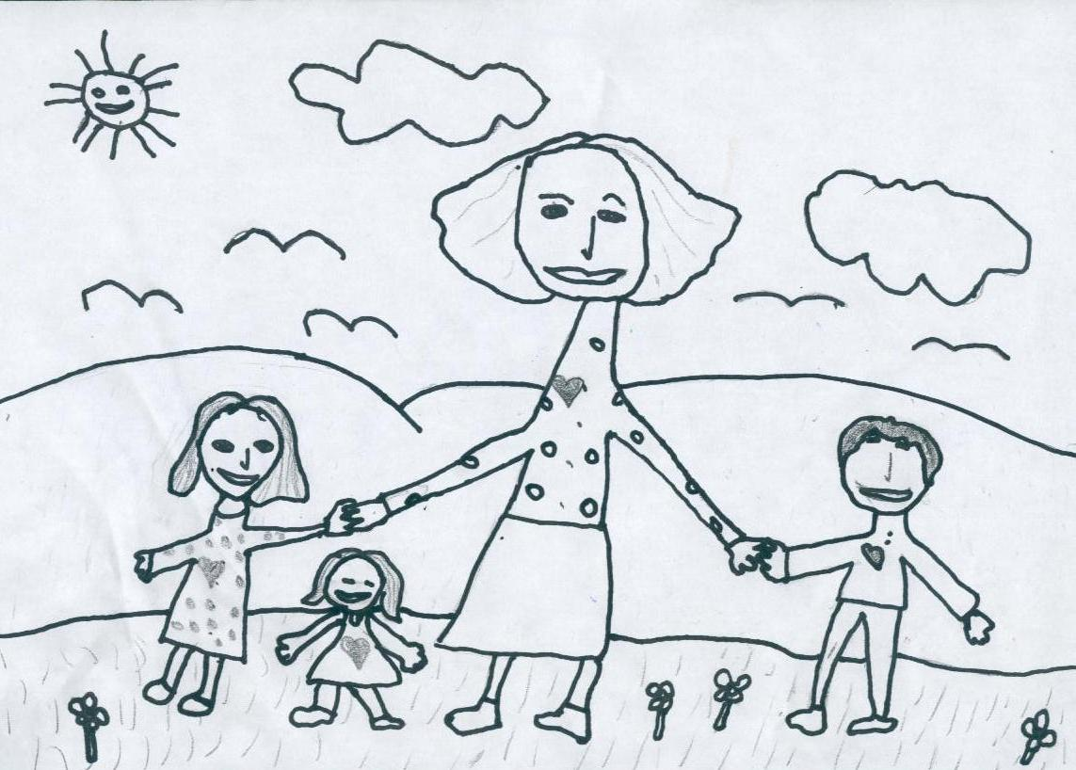

Encourage the children at your ECD centre to draw a picture of their family so that you can learn more about each child’s family as a w

Types of administrative information and documentation

practitioners and parents/guardians know about and follow. These health policies should include information about issues such as, immunisation, HIV and AIDS, exclusion due to specific illnesses, and care of ECD practitioners. In this topic we will discuss some of these policies and how they help to provide a safe and hygienic environment and promote healthy practices.

What policies and guidelines are needed?

The ECD centre needs to draw up guidelines and policies to do with the following health and safety issues:

- Legal responsibilities: The legal responsibility of the ECD centre with regard to the health and safety of its children and staff.
- Environmental policies: How environmental hazards that impact on safety and health will be identified, monitored, prevented and corrected. This includes information about:
  - Who will do the health and safety checks;
  - When and how often the checks will be done; and
  - What is to be done to correct unsafe or unhealthy conditions.
- Policies about cleaning routines and duties.
- Food preparation policies.
- Policies about medical or other emergency and evacuation procedures (see topic 1).
- Outing and transportation policies.
- Staff health policies: How staff health will be monitored and maintained (including immunisation, back-care-lifting heavy objects, HIV and AIDS, and specific illnesses).
- Policies about childhood illnesses and conditions: How childhood illnesses will be monitored and managed, e.g. Children presenting symptoms of common infectious diseases will be referred to a qualified health practitioner; notifiable diseases will be reported by health practitioners to the Department of Health.
- Policies about non-discrimination: How children will be dealt with in a holistic, non-discriminatory and confidential way.

Health and safety records

The ECD centre must keep the following health and safety records:
- A record of each child’s medical history. The parents or caregivers must complete a medical history form for their child when they register the child in the ECD centre. The medical history should include:
  - information about the child’s general state of health;
  - any infectious illnesses that the child has had and the dates when he/she had these illnesses;
  - details regarding the child’s immunisation records;
  - allergies and any other diseases that the child has, e.g. diabetes;
  - the name, address and telephone number of the child’s family doctor, together with permission for him/her to be called out, if necessary; and
  - the name, address and telephone number of the child’s dentist.
- The ECD centre should also keep up-to-date records on the health history of each child. This should include a record of medications to be taken, as well as any illnesses, accidents and incidents.
- Keep notes and records of all injuries, trauma, diseases, and other health and safety issues in the ECD centre as a whole.

Accident report form

It is a good idea to record every accident that happens at your ECD centre, unless it is very minor. If a parent collects their child at the end of the day and she has scraped her knee, or has a bruise on her cheek, the parent will naturally want to know what happened. It is your responsibility to provide parents or caregivers with a detailed record of what happened and how it was dealt with.

A record such as this is also useful for other reasons:
- Doctors or medical professionals may need to know the details of the accident.

- Your ECD centre may keep records of accidents for its own uses, e.g. to monitor possible illnesses and diseases or to keep a proper record of any medicine administered.

The record of an accident should only be written up once the children involved are out of harm’s way and have been attended to. Although you should write it up while the details are still fresh in your mind, do not do so until the incident has been dealt with.

The best way to ensure that all the necessary details are recorded consistently is to use an Accident Report Form, which may be filled out. Keep a number of blank forms at the ECD centre, so that one is always available when you need it. Once you have filled one out, make a photocopy of the completed form and give one copy to the parent or caregiver, while keeping another for the ECD centre’s records.

Case Study of an Accident

Belinda calls you to help Susan who she says has just been burnt by a lighted match that another child was playing with. When you approach Susan you see that she is very upset, although she is not screaming, tears are rolling down her cheeks and she is beginning to shake uncontrollably. Her arm has a red patch on it and she says it is very painful.

Questions | Answers
- How would you ensure that the children did not have access to dangerous materials such as matches? Give 3 solutions to your problem.

- How would you approach Susan?
- How would you assess the situation?
- How would you assess the injury?
- What would you do depending on the severity of the injury?
- How would you treat a minor burn?
- How would you inform Susan’s parents of the accident?

ACCIDENT REPORT FORM
Name of Child: | Age of Child: |  | Gender:
Date of Accident: |  | Time of Accident:
Name of person completing form: |  | Date form completed:
Where accident happened:
Brief description of how accident happened:
Who else was involved:
Objects or equipment involved:
Part of body injured:
What was done to treat the injury:
Child’s comments, thoughts or feelings:
Child’s condition when he/she left our care:
Parent / caregiver:

1. Advised of injury: YES / NO

2. Advised to seek medical assistance: YES / NO
Name of ECD Practitioner present at time of accident:

The ECD centre needs to keep accurate and reliable information, documents and records for different reasons, e.g. for registration purposes; for planning; and for reporting. In this topic we will only look at collecting information about children. The main aims are to:

- Assess what the child can do when first coming into the centre. This is called baseline information. You can then compare progress the child makes to this information to determine the competence they have developed in different areas – physical, social, emotional, cognitive.
- Collect information about where the child needs extra support and design appropriate activities for each child.
- Monitor the progress the child is making and give the parent/caregiver feedback.

How to collect information

There are numerous ways to collect information each day about a child’s progress. For example you can:

- Observe the child in a holistic way to collect information about his or her physical, socio-emotional, cognitive, and normative development.
- Observe the child in particular situations or with particular tasks, e.g. sleeping patterns, feeding patterns, playing, interaction, etc.
- Keep a portfolio of the child’s work (e.g. artwork, crafts, etc).
- Sit with each child and talk about feelings, learning, friends, and so on.
- Monitor the child when he or she arrives in the morning. Make a note about the child’s physical state.
- Throughout the day, pay attention to the child’s socio-emotional behaviour, e.g.
Does he/she play with others? Participate in group, paired and individual activities?
Display any signs of behavioural problems? Observe the child while he or she is interacting with others or playing with a familiar person.

How to record your observations
Here are some ideas on how to observe and record your observations:

- Observe the child in many different situations and while he or she is doing different kinds of activities. Watch out for any situations that affect the child’s behaviour.
- Observe the child at different times of the time, and over a few days. Time of day can influence behaviour, e.g. the child could be hungry, tired, overexcited, etc.
- Always draw on your understanding of child development and learning theory so that you know what you can expect of each child at each age. This is the norm against which you assess individual children.
- Make sure you know what you are looking for and why. For example, do you want to monitor the child’s physical, social and emotional, communication and language, cognitive skills?
- Keep a written record of all your observations. Write up notes at the time of the observation or shortly afterwards, while they are still fresh in your mind. You can use an observation checklist or a journal.
- Include the following in your observation records:
- The child’s name and age.
- The date and time.
- How long you observed the child: You need to watch the child for long enough so that you have a broad picture of the child’s behaviour.
- The purpose and method of observation.
- Where you observed the child, e.g. inside, outside, art or creative area, discovery table, book area, fantasy play area, puzzle corner, etc.
- Describe the behaviour you observe and include any relevant comments or actions that the child does.
- Comment on the child’s behaviour, e.g. was it appropriate, is there progress, does the child need extra support, etc?
- Comment on any background issues that might have influenced the child’s behaviour (e.g. home situation, time of day, child’s health, etc.)
- Comment on or evaluate the child’s behaviour using the developmental norm that is appropriate to his or her age or stage of development.
- Provide a plan for supporting the child. This might include referring the child, designing remedial or enrichment activities, speaking to the parents/caregiver, etc.
- Keep a file on each child in which to store all your observation records and reports.
- Review your observation records regularly to assess the child’s progress. Use these observations to plan your daily activities.

On the following pages are some examples that you can use or adapt to record different kinds of information about a child.

Example observation sheet for observing child’s physical skills

Observation checklist: Children’s physical skills
Child’s name:
Age of child:
Date:
Time:
Duration of observation:
Setting:
Observation method:
Contextual (background) factors:
 | 4: excellent | 3: good | 2: age appropriate | 1: weak
Gross motor skills (e.g. Walks, runs, climbs, can pedal a tricycle, etc)
Activity observed:

Fine motor skills (e.g. Colours in, writes, ties shoelaces, etc)
Activity observed:

Eye-hand co-ordination
Activity observed:

Comments:

Plan for supporting the child:

Example observation sheet for observing child’s language development

Observation checklist: Child’s language development

Child’s name:
Age of child:
Date:
Time:
Duration of observation:
Setting:
Observation method:
Contextual (background) factors:

 | 4: excellent | 3: good | 2: age appropriate | 1: weak
Listening/attention
Child enjoys simple stories, songs and rhymes.
Can keep busy for about 10–15 minutes and finish activities.
Has a good attention span (longer than 15 minutes).
Can follow complex directions
Speaking
Knows one or two nursery rhymes and can find them in a picture book.
Can tell own simple story from pictures and books.
Can remember and repeat stories.
Can create own stories.
Uses 2–3 words in a sentence.
Uses 3–5 words in a sentence.
Uses about 5–8 words in a sentence.
Can learn name, address and phone number.
Question words
Can ask question, ‘why’?
Can ask ‘who’, ‘what’, ‘where’ and ‘why’ questions.
Can ask any questions about everything.
Uses words like ‘because’.
Concepts
Understands ‘now’, ‘soon’ and ‘later’.
Understands smallest, tallest, biggest, same, more, in, on, under and above.
Understands ‘before’, ‘after’, ‘above’ and ‘below’.
Understands concepts related to number, size, weight, colours, textures, distance, position and time.
Understands ‘more’, ‘less’ and ‘the same’.
Numbers and counting
Can count to three.
Can count to 10.
Understanding
Can understand 50% of what you say.
Can understand 80% of what you say.
Can understand 100% of what you say.
Colours and shapes
Can name common colours like red, green, blue and yellow.
Can name basic colours and a few shapes.
Alphabet and reading
Recognises some letters of the alphabet and familiar words.
Understands that books are read from left to right and from top to bottom.
Comments:

Plan for supporting the child:

Example observation sheet for observing social interaction in a group
Observation checklist: Interaction with others

Child’s name:
Age of child:
Date:
Time:
Duration of observation:
Setting:
Observation method:
Contextual (background) factors:
Description of the task:

 | Yes | No
Did the child understand the group’s task?
Did the child have to do the task?
Did he/she do it?
Did we co-operate by talking, listening and sharing work?
Did he/she participate in any decision-making?
Did he/she help and support other members of the group?
Did he/she take turns?
Did he/she express agreement and disagreement politely?
Did he/she show consideration for differently-abled or special needs children?
Comment on social interaction in group:

Plan for supporting the child:

FORMATIVE ASSESSMENT

• IAC0102 Identify and describe the various parent initiatives used in own work setting, including support for parents of children experiencing barriers to learning

• IAC0104 Explain the process involved in planning and preparing for parent meetings
(Weight 100%)

References

Active listening. http://en.wikipedia.org/wiki/Active_listening. Downloaded on 12 Aug 2008.

Brakefield-Caldwell, W. 2007. Community-Based Participatory Research &
Capacity building. http://en.wikipedia.org/wiki/Capacity_building Downloaded on 13 Aug 2008.

Collaboration Building. Published on http://rd100.cceb.med.upenn.edu/crcu_html/roadmap/mtgs/may_steering_2007/SP_McGranaghan_color.pdf Downloaded 5 Sept 2008.

Community development. 2007. Published on http://en.wikipedia.org/wiki/Community_development Downloaded 2 Sept 2008.

Dutschke, M. Children's rights to social services. Published on http://www.ci.org.za/depts/ci/enews/June2005/social_services.htm Downloaded on 15 Aug 2008.

Early Childhood Development practitioner training. Published on http://www.sasix.co.za/projects/view/ECD-KZN-FEB-0001/ Downloaded 3 Sept 2008.

Family And Marriage Society of South Africa Published on http://www.famsa.org.za/ Downloaded 8 Sept 2008.

http://www.ncrel.org/sdrs/areas/issues/educatrs/leadrshp/le300.htm Downloaded 2 Sept 2008.

McClure, R. 2007. Tips for a Successful Parent-Teacher Conference. Published on http://childcare.about.com/b/2007/05/16/tips-for-a-successful-parent-teacher-conference.htm Downloaded 8 Sept 2008.

Orans, L. P. 1996. What are values? Published on http://www.pinetreeweb.com/values.htm Downloaded 4 Sept 2008.

Principles: What are they anyway? Published on http://dspace.dial.pipex.com/town/street/pl38/princ.htm Downloaded on 3 Sept 2008.
Singer, P. (1993) Practical Ethics, Second edition (p.10), Cambridge University Press: Cambrdige

The Children’s Amendment Act (Act 41 of 2007)

The South African Council for Educators. Published on http://www.sace.org.za/ Downloaded 8 Sept 2008.

What are ethics? Published on www.allaboutphilosophy.org/what-are-ethics-faq.htm Downloaded 9 Sept 2008.

Appendices
All qualifications and part qualifications registered on the National Qualifications Framework are public property. Thus the only payment that can be made for them is for service and reproduction. It is illegal to sell this material for profit. If the material is reproduced or quoted, the South African Qualifications Authority (SAQA) should be acknowledged as the source.

SOUTH AFRICAN QUALIFICATIONS AUTHORITY

REGISTERED QUALIFICATION:

Occupational Certificate: Early Childhood Development Practitioner

SAQA QUAL ID | QUALIFICATION TITLE
97542 | Occupational Certificate: Early Childhood Development Practitioner
ORIGINATOR
Development Quality Partner - ETDPSETA (Education)
PRIMARY OR DELEGATED QUALITY ASSURANCE FUNCTIONARY |  |  | NQF SUB-FRAMEWORK
- |  |  | OQSF - Occupational Qualifications Sub-framework
QUALIFICATION TYPE | FIELD |  | SUBFIELD
Occupational Certificate | Field 05 - Education, Training and Development |  | Early Childhood Development
ABET BAND | MINIMUM CREDITS | PRE-2009 NQF LEVEL | NQF LEVEL | QUAL CLASS
Undefined | 131 | Not Applicable | NQF Level 04 | Regular-ELOAC
REGISTRATION STATUS |  | SAQA DECISION NUMBER | REGISTRATION START DATE | REGISTRATION END DATE
Registered |  | IEXC 0002/16 | 2016-02-17 | 2019-02-17
LAST DATE FOR ENROLMENT |  | LAST DATE FOR ACHIEVEMENT
2020-02-17 |  | 2023-02-17

In all of the tables in this document, both the pre-2009 NQF Level and the NQF Level is shown. In the text (purpose statements, qualification rules, etc), any references to NQF Levels are to the pre-2009 levels unless specifically stated otherwise.

This qualification does not replace any other qualification and is not replaced by any other qualification.

PURPOSE AND RATIONALE OF THE QUALIFICATION

Purpose:
The purpose of this qualification is to prepare a learner to operate as an Early Childhood Development Practitioner.
An Early Childhood Development Practitioner plans and prepares early childhood activities, facilitates and mediates learning, observes and assesses the progress of children, and reflects on learning in an inclusive, play-based environment to support holistic development of children (from conception - school going) in different centre-based or non-centre based settings.
A qualified learner will be able to:
• Plan and prepare broad-phase learning environment and stimulating activities that meet the holistic needs of all children in centre-based or non-centre-based settings.
• Facilitate and mediate all aspects of the daily programme in a centre-based or non-centre based setting.
• Observe, assess and record each child's progress according to the age and stage.
• Compile a report of each child's progress.
• Maintain and promote the well-being, health, nutrition, safety and protection of children.
Rationale:
The Occupational Certificate: Early Childhood Development has been designed to meet the needs and interests of the early childhood development sector in a variety of settings and contexts with an inclusive focus on education, health and safety issues, amongst others. There is a vast need for early childhood development services and it is critical that the field must be served by competent practitioners. In order to meet the needs at early childhood development level, it is important to be able to identify and recognise competent early childhood development practitioners who are able to work in centre-based and non-centre-based early childhood development settings.
This qualification will provide a means to give recognition to practitioners at an entry level, thus making it possible for practitioners to increase their employment prospects within the Department of Basic Education. The Department of Social Development, through the registration of early childhood development centres and/or sites, may also provide business opportunities to successful practitioners who may wish to establish early childhood centres and/or sites. It will also provide access to a recognised career path and at the same time provide the field with suitably qualified professional practitioners.
The qualification will provide opportunities to people who wish to enter and/or continue learning in the early childhood development field, which include the employed, under-employed but not qualified, and school leavers. Every child has the right to high-quality, holistic education and care which forms the critical foundation for further development and learning from childhood into adulthood.
This necessitates the universal availability of high-quality early childhood development and education as a vital strategy to yield personal and long-term benefits to individual children, their families and the society at large.
Early childhood development is an essential component of economic development within the framework of child care services. Changing social and economic needs require parents to enter the labour market. Therefore quality early childhood development service provision is required to meet growing demands in the country, both in urban and rural settings.

LEARNING ASSUMED TO BE IN PLACE AND RECOGNITION OF PRIOR LEARNING

Recognition of Prior Learning (RPL):
RPL for access to the external integrated summative assessment: Accredited providers and approved workplaces must apply the internal assessment criteria specified in the related curriculum document to establish and confirm prior learning. Accredited providers and workplaces must confirm prior learning by issuing a Statement of Results or certifying a Work Experience Record.
RPL for access to the Qualification: Accredited providers and approved workplaces may recognise prior learning against the relevant access requirements.
Entry Requirements:
• National Certificate Vocational (NCV) at NQF Level 3.
Or
• Any other NQF Level 3 qualification.

RECOGNISE PREVIOUS LEARNING?

Y

QUALIFICATION RULES

This qualification is made up of the following compulsory Knowledge Modules, Practical Skill Modules and Work Experience Modules totalling 131 Credits:
Knowledge Modules: 43 Credits:
• 234201000-KM-01, Introduction to the early childhood development sector, at NQF Level 4, 4 Credits.
• 234201000-KM-02, Theories and Perspectives of Child Development, at NQF Level 5, 6 Credits.
• 234201000-KM-03, Planning and Programme Development in early childhood settings, at NQF Level 4, 8 Credits.
• 234201000-KM-04, Facilitation and mediation of active learning, at NQF Level 5, 12 Credits.
• 234201000-KM-05, Observation and assessment in early childhood development, at NQF Level 4, 4 Credits.
• 234201000-KM-06, Promotion of health, safety and well-being of children, at NQF Level 4, 6 Credits.
• 234201000-KM-07, Administration for early childhood development services and programmes, at NQF Level 3, 3 Credits.
Practical Skill Modules; 43 Credits:
• 234201000-PM-01, Plan and prepare inclusive educational activities and routines using an approved programme based on the curriculum framework, at NQF Level 4, 12 Credits.
• 234201000-PM-02, Facilitate and mediate active learning in an integrated and holistic learning programme, at NQF Level 5, 9 Credits.
• 234201000-PM-03, Observe, assess, record and report each child's progress according to the age and stage, at NQF Level 4, 4 Credits.
• 234201000-PM-04, Support and promote the health, nutrition, safety, protection and well-being of children, at NQF Level 4, 12 Credits.
• 234201000-PM-05, Build and maintain collaborative relationships with parents and other service providers, at NQF Level 4, 3 Credits.
• 234201000-PM-06, Prepare and maintain administrative systems, at NQF Level 3, 3 Credits.
Work Experience Modules; 45 Credits:
• 234201000-WM-01, Learning programme and routines planning and preparation process, at NQF Level 4, 13 Credits.
• 234201000-WM-02, Processes of facilitating and mediating the learning programme in a variety of contexts, at NQF Level 4, 15 Credits.
• 234201000-WM-03, Processes of observation, assessment, recording and reporting on children's learning and development, at NQF Level 4, 7 Credits.
• 234201000-WM-04, Processes and procedures of promoting the health, nutrition, safety, protection and well-being of children in an early childhood development setting, at NQF Level 4, 10 Credits.

EXIT LEVEL OUTCOMES

1. Plan and prepare broad-phase learning environment and stimulating activities that meet the holistic needs of all children in centre-based or non-centre-based settings.
2. Facilitate and mediate all aspects of the daily programme in a centre-based or non-centre based setting.
3. Observe, assess and record each child's progress.
4. Compile a report of each child's progress.
5. Maintain and promote the well-being, health, nutrition, safety and protection of children.

ASSOCIATED ASSESSMENT CRITERIA

Associated Assessment Criteria for Exit Level Outcome 1:
• In inclusive physical learning environment for the selected broad phase is set up to encourage play, exploration and learning for all children in a centre-based or non-centre-based setting.
• The concepts of inclusion, diversity, equality, cultural and language sensitivity in early childhood development are explained in accordance with legal and centre policy requirements.
• A daily plan for one broad phase that reflects diversity, culture and inclusivity is designed and developed using developmentally appropriate activities, resources and equipment.
• The activities are planned and prepared, and resources are adapted to meet the learning and developmental needs, including special needs, of a selected broad phase within the planned programme.
• Factors to be considered when planning for the learning and development of children in a centre-based or non-centre-based setting are identified and explained.
Associated Assessment Criteria for Exit Level Outcome 2:
• The importance and benefits of both indoor and outdoor play are explained with examples.
• Types of play that support the areas of learning and development are identified and analysed as outlined in the early childhood development curriculum.
• A daily plan for one broad phase is implemented using appropriate activities and resources that reflect diversity, culture and inclusivity.
• Reasons why both adult-directed and child-initiated play and learning activities are important for children are explained, in relation to development and learning of children.
• The needs of all children in a centre-based or non-centred-based setting are identified and mediated through interactions, communication, guidance and care.
• The facilitation of child-initiated and adult-directed activities is demonstrated.
• The development of children's language and thinking is mediated through integrated activities using different methods.
• Barriers to play-based learning in an early childhood development setting are identified and described with examples.
Associated Assessment Criteria for Exit Level Outcome 3:
• The importance of observing, assessing and documenting children's learning and development in a centre-based setting is explained.
• Different assessment techniques appropriate to early childhood development are identified and explained in order to assess the child's development and learning.
• Different methods for gathering information of children's development and learning are identified and described with examples.
• Different methods for recording children's learning and development are identified and described with examples.
• Possible factors which may impede children's progress are identified and explained with examples.
• Relevant tools, templates and documentation are used to produce written evidence of observation and assessment that meets the criteria for sound assessment practices of one child, using.
• Observation and assessment methods to detect warning signs of developmental, emotional or health-related problems, including special needs, are applied, and findings are interpreted and recorded using relevant templates.
• Child's records that meet the centre's policy requirements are completed.
Associated Assessment Criteria for Exit Level Outcome 4:
• Observation and assessment records are evaluated to determine children's developmental milestones and possible individual differences that affect children's growth and development.
• The achievement of learning goals and targets is reviewed to track children's progress.
• A progress report is developed integrating all relevant information pertaining to the child's progress, with recommendations in accordance with centre reporting requirements.
• A plan is developed using assessment results to shape learning opportunities and needs of children, to achieve positive outcomes.
• The importance of working with families to develop strategies with children when there are behavioural concerns is explained in order to promote positive behaviour.
• Information gathered about children's progress is analysed, interpreted and used to support individual's development and learning, and to inform practice.
Associated Assessment Criteria for Exit Level Outcome 5:
• Different types of accidents and emergency situations which may occur in an early childhood development setting are identified and described.
• An action plan on how to respond to accidents and emergency situations is developed in accordance with health and safety legislation and regulations, and the centre's policy requirements.
• The nutritional requirements of a healthy diet for children are outlined by means of a weekly menu for all children, taking into account special dietary requirements.
• Techniques of promoting healthy lifestyles for babies and children are identified and described with examples.
• Given a case scenario, the signs of distress, maltreatment, abuse or neglect are identified and described, and recommendations on how to deal with them reflect centre policies in terms of rules of confidentiality and reporting procedures, including legal requirements.
• Environmental dangers, infections and risks that may affect children, including children with special needs, in the centre-based or non-centre-based setting, are identified and explained with examples.
• Procedures for recording and reporting accidents and other emergencies in own setting are described in accordance with legal and centre policy requirements.
• Measures for the prevention and spread of infection in early childhood development settings are identified and described in accordance with legislation, regulations and guidance that apply to infection prevention and control.
Integrated Assessment:
Integrated formative assessment:
The skills development providers will use the curriculum to guide them on the stipulated internal assessment criteria and weighting. They will also apply the scope of practical skills and applied knowledge as stipulated by the internal assessment criteria. This formative assessment leads to entrance into the integrated external summative assessment.
Integrated Summative Assessment:
An external integrated summative assessment, conducted through the relevant QCTO Assessment Quality Partner, is required for the issuing of this qualification. The external integrated summative assessment will focus on the Exit Level Outcomes and Associated Assessment Criteria.

INTERNATIONAL COMPARABILITY

The aim of the international comparability study was to examine early childhood development qualifications of other countries at international, regional and African contexts to benchmark best practice in this field. The study examined occupationally-based early childhood development qualifications and related curricula, including competencies as standards of knowledge and skills of early childhood development professionals responsible for the care and education of children at different levels. The comparability exercise focused on three countries, namely United States of America, United Kingdom and Kenya.
The findings of the study indicate that the sections on training and qualifications of Early Childhood Education (ECE) staff in ECE centres differ markedly in terms of duration and levels of study.
United States of America:
The US Delaware Department of Education identified competencies of early childhood professionals and divided the ECE staff into four levels. Level 1 practitioners are required to assist, Level 2 to implement, Level 3 to design and develop, and Level 4 to manage and lead. All staff is required to have knowledge and skills in the following content areas:
• Child Development.
• Environment and Curriculum.
• Promoting socio-emotional development.
• Observation and assessment.
• Health, Safety and Nutrition.
• Working with Families and Professionalism.
These content areas are identifiable in the countries compared, which are the United Kingdom and Kenya with professionalism and legislation/policy frameworks and reflective practice being used interchangeably, diversity or inclusion being highlighted, and aspects of qualification design, qualification evaluation, context-specific interventions, children's welfare, specific focus areas of language, etc. and activities fore-grounded in the qualifications offered, comparing favourably with the South African early childhood development outcomes.
United Kingdom:
Course Title: CACHE Level 3 Childcare and Education:
This is a work-based, competence-based qualification that prepares learners to work with children and young people with their families in a variety of settings. The job roles are listed as follows:
• Child-minder.
• Crèche Leader.
• Nursery Nurse.
• Nursery Supervisor.
• Playgroup Leader.
• Pre-school Leader.
• Special Educational Needs Supporter.
• Toy Library Leader.
The competencies reflect the skills and knowledge needed to do a job effectively; to work on their own initiative, planning and organising their own work; and supervising others. This qualification is pitched at the level equivalent to the South African Occupational qualification developed for ECD Practitioners.
The qualification structure is as follows:
• Unit 1: An introduction to working with children.
• Unit 2: Development from conception to age 16 years.
• Unit 3: Supporting children.
• Unit 4: Keeping children safe.
• Unit 5: The principles underpinning the role of the practitioner working with children.
• Unit 6: Promoting a healthy environment for children.
• Unit 7: Play and learning in children's education.
• Unit 8: Caring for children.
• Unit 9: Development of professional skills within children's education.
The CACHE Level 3 Diploma in Early Years Education and Care (Early Years Educator) prepares learners to become Early Years Educators, enabling them to work with children from birth to 5 years and gain knowledge of children aged 5 to 7 years.
Kenya:
GEMS Training Education and Leadership Academy:
Title: CACHE Level 3 Diploma for the Early Years Workforce (Early Years Educator) (QCF).
Early Childhood Development Education in Kenya is under the care of parents, community, non- governmental organisations (NGO), religious organisations and other private providers. In Kenya the Nursery Teacher Certificate course (2 years) is replaced by the KHA (Kindergarten Teacher Diploma) for low-budget private pre-schools that serve low-income families. Further to this there is little information available about ECE staff that works out of centres such a playgroup facilitators, home-visitors or toy librarians. The search indicated that the mostly used education and training in early childhood development for practitioners is offered through GEMS Education in partnership with CACHE (Council for Awards in Care, Health and Education). GEMS Education is providing globally recognised Early Years Practitioner accredited qualifications in sixteen countries in the world. The CACHE Level 3 Diploma for the Early Years Workforce (Early Years Educator) (QCF) prepares learners to become Early Years Educators, enabling them to work with and care for children from birth to 5 years and gain knowledge of children aged 5 to 7 years. It is a work-based qualification that recognises effective practice by assessing the skills, knowledge and understanding of practitioners, including child development, teaching methods and appropriate provision for young children.
The units are structured around four themes as follows:
• Unit 1: Health and well-being.
• Unit 2: Legislation, frameworks and professional practice.
• Unit 3: Play, development and learning for school readiness.
• Unit 4: Professional development.
The duration of the full diploma is 12 months and it is offered through online and classroom sessions (face-to-face) during six weekend training workshops spread throughout the year. Although the mode of delivery varies with this qualification, the course content and duration compare favourably with the occupational qualification.
Conclusion:
The findings of the research done in the countries above reveal that the Early Childhood Development Practitioner Occupational Qualification compares favourably with that of the countries studied. There are many similarities in terms of the scope, content and duration of the qualification.

ARTICULATION OPTIONS

Horizontal Articulation:
• Further Education and Training Certificate in Early Childhood Development, NQF Level 4, SAQA ID: 58761.
Vertical Articulation:
• National Certificate in Early Childhood Development, NQF Level 5, SAQA ID: 58761.
• National Diploma in Early Childhood Development, NQF Level 5, SAQA ID: 64650.

MODERATION OPTIONS

N/A

CRITERIA FOR THE REGISTRATION OF ASSESSORS

N/A

NOTES

Qualifying for external assessment:
In order to qualify for the external summative assessment, learners must have a copy of a completed and signed Statement of Work Experience as well as proof of successful completion of the following subjects and Modules or Alternative Programmes where applicable:
Foundational Learning Competence is a pre-requisite for access to the external integrated summative assessment.
Additional legal or physical entry requirements:
None
Criteria for the accreditation of providers:
Accreditation of providers will be done against the criteria as reflected in the relevant Curriculum on the QCTO website.
The Curriculum Title and Code is: 234201000: Early Childhood Development Practitioner.
This Qualification covers the following trades as recorded on the NLRD:
• Not applicable as this Qualification is not a trade.

LEARNING PROGRAMMES RECORDED AGAINST THIS QUALIFICATION:

NONE

PROVIDERS CURRENTLY ACCREDITED TO OFFER THIS QUALIFICATION:

This information shows the current accreditations (i.e. those not past their accreditation end dates), and is the most complete record available to SAQA as of today. Some Primary or Delegated Quality Assurance Functionaries have a lag in their recording systems for provider accreditation, in turn leading to a lag in notifying SAQA of all the providers that they have accredited to offer qualifications and unit standards, as well as any extensions to accreditation end dates. The relevant Primary or Delegated Quality Assurance Functionary should be notified if a record appears to be missing from here.

NONE

All qualifications and part qualifications registered on the National Qualifications Framework are public property. Thus the only payment that can be made for them is for service and reproduction. It is illegal to sell this material for profit. If the material is reproduced or quoted, the South African Qualifications Authority (SAQA) should be acknowledged as the source.

